Friday, 29 April 2005

F.A.O. Mr. Jilani BEN HADDADA
SECRETARY GENERAL
PAN AFRICAN POSTAL UNION

P.O. Box 6026
Arusha
United Rep. of Tanzania

Dear Mr Haddada,

With reference to you letter dated today. I regret to inform you that as I will still be in the employ of Escher Group Limited, I will not be able to attend the meeting you have scheduled for the 20th of May 2005.

I suggest that draft documents are agreed between us in advance of the meeting and that you send me the final documents once they are signed. Immediately I receive these documents, I will counter sign and return them to you and I will resign my post with my current employer.

In the mean time, if you need any information from me for the meeting, please do not hesitate to ask.

Yours Faithfully,

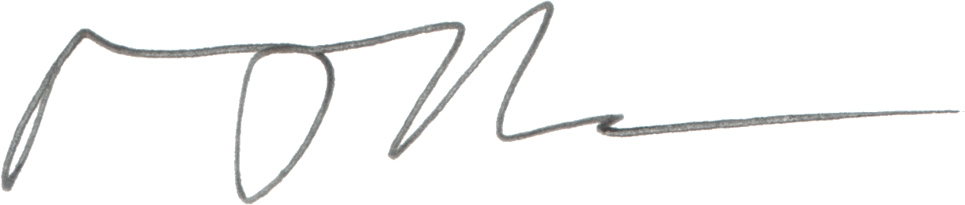

Mark J. Durbin
Mark@CykorSystems.com

